James Young

**Problem 1**

**1. In HW2, what were the results of the anova output? (1 sentence)**

We originally rejected H0 based strictly on ANOVA results, but later found that the sample data was not normal through a Shapiro-Wilkes and Levene test.

**2. Most post-hoc comparison procedures are restricted to testing contrasts that compare pairs of means, state the null hypothesis and alternative of a pair-wise comparison.(state the hypothesis)**

H0: for all values $i$ and $j$

H1:  for at least on pair of means

**3. Pairwise comparisons are not really that restrictive, what does this allow you to do with the means? (1 sentence)**

This allows you to rank the means.

**4. State the 3 popular methods for comparing paired comparisons**

Fisher LSD procedure, Tukey’s procedure, and Duncan’s Multiple Range Test.

**5. Using R, obtain the results for Tukey and Duncan’s test and place them side-by-side like the example below: (Make sure to label which is which. Put Tukey 1st and Duncan 2nd).**

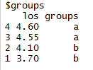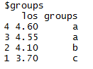

Tukey’s Duncan’s

For reference in problem: 1=group A, 2=group B, 3=group C, 4=group D

**6. Interpret the results of the Tukey Test**

The Tukey test shows 2 different groups based upon analysis of the means with experimental groups 4 and 3 composing group “a”, and experimental group 2 and 1 composing “b”.

**7. Interpret the results of the Ducan’s Test**

Duncan’s Test shows groups 4 and 3 were grouped together as a, group 2 was its own group “b”, and group 1 was its own group “c”.

**8. State the hypothesis of the contrast(s)**

Contrast 1 Contrast 2

H0 : H01 :

H1 :  H11 :

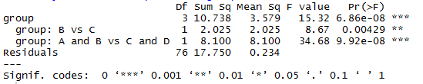**9. Provide the R snip of your results**

**10. Use the decision rule using step 4 of 3.2.7**

Contrast 1 had a calculated p-value of 0.00429. 0.00429<0.05, therefore we reject H0. Contrast 2 had a calculate p-value of 9.92e-08. 9.92e-08<0.05, therefore we reject H01.

**11. Interpret the results in the context of the problem**

Rejection of H0  in Contrast 1 means that group there is a significant difference in length of stay between patients treated with group B anesthetic versus group C anesthetic. Rejection of H01  in Contrast 2 means that there is a significant difference in length of stay between patients treated with group A and B anesthetic versus group C and D anesthetic. This leads to the inference that group C and D are safer than A and B.

**12. Are these two contrasts orthogonal? Justify your answer**

No, they are not orthogonal.

|  |  |  |  |  |
| --- | --- | --- | --- | --- |
|  | Group A | Group B | Group C | Group D |
| Contrast 1 | 0 | 1 | -1 | 0 |
| Contrast 2 | 1 | 1 | -1 | -1 |
| Contrast 2 x Contrast 1 | 0 | 1 | 1 | 0 |
| Grand Total | $≠$ 0 | | | |

When adding up the products of contrast coefficients, the total could not equal 0, even if we switched coeffecient’s around. Therefore, these contrasts are not orthogonal.

**Problem 2**

**1. State the hypothesis**

H0:

H1: at least one mean is not equal

**2. Provide a snip of the ANOVA Table**

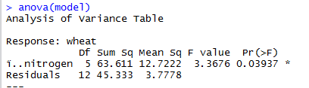

**3. Calculate the test statistic (F Statistic only)**

**F= $\frac{MS_{Between}}{{MS}_{within}}$ = $\frac{12.7222}{3.7778}=3.3676$**

**4. Use the decision rule using step 4 of 3.2.7**

Our calculated F statistic is 3.3676. The F statistic at α=0.05 with 5 df in the numerator and 12 df in the denominator is 3.11. 3.3676 < 3.11, therefore we reject H0

**5. Interpret the results in the context of the problem**

This shows that not all means are the same and we can infer that nitrogen has an effect on wheat yield.

**A close up of a map

Description generated with very high confidence6. Provide only the qqplot. Examine the residuals distribution from the qqplot and comment on the distribution.**

The distribution of residuals appears to be normal and

Balanced through visual investigation.

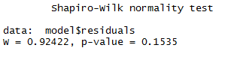**7. Perform the Shapiro-Wilks Test to test the normality. You need hypothesis test, R snip with the result and the decision rule. Interpret results**

Hypothesis (with )

H0 : All samples came from normal distribution

H1: Any sample did not come from a normal distribution

Decision: Calculated p-value = 0.1535. 0.1535 > 0.01 therefore we fail to reject H0.

The data is a normal distribution.

**8. State the hypothesis of the contrast(s)**

Contrast 1 Contrast 2

H0 : L1 = 0 H01 : L2 = 0

H1 = L1 H11 = L2

Where L1 =

And L2 =

**9. Provide the R snip of your results like above**

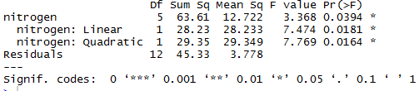

**10. Use the decision rule using step 4 of 3.2.7**

Linear calculated p-value is 0.0181. 0.0181<0.05, therefore we reject H0 of contrast 1. Quadratic calculated p-value is 0.164. 0.0164<0.05, therefore we reject H01 Contrast 2.

**11. Interpret the results in the context of the problem**

We rejected H0 and H01, which means both linear and quadratic trends could accurately represent the relation between nitrogen and wheat yield.

**12. Determine whether a linear or quadratic trend may be used to describe the relationship of yield to amount of nitrogen. Justify your answer.**

The contrast test for the quadratic trend rejects H02 and had a lower p value which makes it the more prudent choice for the model.

R code

